**Project Report Template**

**Title of Project:** EduAid — Free E-Learning & Mentorship Web Application

**Name of the Innovator:** Vishwa  
**Start Date:** 27-10-2025

**End Date: -10-2025**

***Day 1: Empathise & Define***

*Step 1: Understanding the Need*

* Which problem am I trying to solve?

I’m solving the problem of unequal access to quality education and mentorship for students from rural and underprivileged backgrounds. Many learners lack exposure to qualified teachers, proper learning materials, and career guidance. EduAid helps bridge this gap by providing free online study resources and mentorship opportunities through a single digital platform.

* Who is affected by this problem?
* How did I find out about this? [Select whichever is applicable]
* Interviews
* Observation
* Online Research
* AI Tools

*Step 2: What is the problem?*

The problem is the **unequal access to quality learning and mentorship**, which creates an educational gap between privileged and underprivileged students.  
**EduAid** aims to solve this by providing a **free, inclusive, and interactive web platform** offering study materials, expert mentorship, and peer learning opportunities.

Why is this problem important to solve?

Education is a key factor for social development. Providing access to learning and mentorship opportunities can empower underprivileged students to achieve academic success, gain confidence, and build a better future.

**Take-home task**

Ask 2-3 people what they think about the project:

* **1. Student (Rural College Student):**  
  “This platform will help us learn from teachers and mentors even if we can’t attend tuition classes.”
* **2. Teacher (Career Guidance Teacher):**  
  “EduAid can help us reach students who are genuinely interested in learning but lack access to resources.”
* **3. Parent (From a Rural Area):**  
  “I like this idea because it will help my child study with good materials for free.”

*AI Tools you can use for Step 1 and 2:*

**AI Tools Used:**

**1. ChatGPT (OpenAI)**

* **Used to design chatbot conversations that simulate mentor-student interaction.**
* **Helps generate study content, FAQs, and summaries of educational topics.**
* **Assisted in writing and organizing the project documentation, including content for discussion forums and user guidance.**

**2. Figma AI**

* **Used for UI/UX prototyping and to automatically generate responsive layouts for the EduAid web interface.**
* **AI-assisted features helped create consistent design components such as dashboards, forums, and chat panels.**

**3. Canva AI**

* **Used for poster, logo, and infographic design for the EduAid presentation.**
* **AI design recommendations helped improve the project’s visual appeal and clarity.**

**4. Meta MGX**

* **Used as a no-code AI web development platform to rapidly create interactive web prototypes.**
* **Supported drag-and-drop integration of features like forms, dashboards, and user authentication.**
* **Enabled quick testing of learning modules without manual programming.**

**5. Perplexity AI / Google Gemini (Optional)**

* **Used for research and gathering insights about online education trends, user needs, and mentorship systems.**
* **Helped in identifying relevant data for the platform’s problem-solving approach.**

***Day 2: Ideate***

*Step 3: Brainstorming solutions*

* List **at least 5 different solutions** (wild or realistic):
* **E-Learning Website with Free Study Resources**  
  – A web-based platform providing open access to study materials, notes, and video tutorials for students from various educational backgrounds.
* **AI-Powered Mentorship Chatbot**  
  – A virtual assistant that helps students find answers to academic queries, gives study tips, and connects them with suitable mentors for guidance.
* **Online Discussion Forum for Students and Teachers**  
  – A community-driven Q&A forum where students can post doubts and get instant help from peers or teachers.
* **Skill Enhancement & Progress Tracking Portal**  
  – A web system where learners can track their academic progress, complete skill-based modules, and earn badges for motivation.
* **Live Mentorship and Tutoring Sessions**  
  – Integration of live video sessions or chat features allowing students to directly interact with teachers or mentors for personalized guidance.
* *(Bonus Idea)* **Mobile-Friendly Learning App**  
  – A lightweight Android/iOS version of EduAid so that rural students with limited devices can access learning materials easily.

Top of Form

Bottom of Form

*Step 4: My favourite solution:*

*My favorite solution is* ***EduAid****, a free web-based e-learning and mentorship platform.  
It allows students to access study materials, ask questions, and connect with mentors easily.  
The platform includes discussion forums, progress tracking, and AI chat support for guidance.  
EduAid helps bridge the education gap for underprivileged learners.  
It’s simple, accessible, and impactful for students everywhere.*

*Step 5: Why am I choosing this solution?*

I am choosing **EduAid** because it promotes equal access to education for all students.  
It combines learning, mentorship, and discussion in one easy-to-use platform.  
The project helps students who cannot afford paid online courses.  
It provides real-time guidance and progress tracking for better learning outcomes.  
EduAid is practical, impactful, and supports social development through education.

*AI Tools you can use for Step 3-5:*

**AI Tools for Step 3–5**

**1** **ChatGPT (OpenAI)**

* **Used to brainstorm innovative ideas for e-learning and mentorship solutions.**
* **Helps write and refine content for platform features like study materials, discussions, and chatbot interactions.**
* **Supports generating clear and concise documentation for project planning and structure.**

**2 Figma AI**

* **Used to design the user interface (UI) of the EduAid web platform.**
* **AI-assisted layout suggestions help in creating an accessible and student-friendly dashboard.**
* **Enables quick visualization of how students, teachers, and mentors will interact.**

**3 Meta MGX (No-Code AI Builder)**

* **Used to prototype the EduAid web app without manual coding.**
* **Allows drag-and-drop creation of pages, login systems, and mentorship dashboards.**
* **Simplifies testing different features and workflows before full development.**

**4 Canva AI**

* **Used for designing posters, presentations, and infographics for the EduAid project.**
* **AI suggestions help create consistent color themes and educational visuals.**

**5 Perplexity AI / Gemini (Google AI)**

* **Helps in researching trends in online education and mentorship programs.**
* **Provides data insights to support solution design and implementation.**

***Day 3: Prototype & Test***

*Step 6: Prototype – Building my first version*

What will my solution look like?

* **Home Screen:** Welcomes users with a brief introduction about EduAid and options to sign up as a **Student**, **Teacher**, or **Mentor**.
* **Dashboard:** Displays the user’s enrolled subjects, uploaded materials, and progress tracker.
* **Discussion Forum:**An open Q&A section where students can ask questions, interact with mentors, and share ideas.
* **Mentorship Chat:** A private one-on-one chat system for personalized student–mentor interaction.
* **Progress Tracking Dashboard:** Uses **charts and analytics** to show completed lessons, time spent, and achievements.
* **Design Style:**
* Simple, intuitive, and accessible interface.
* Light color scheme for easy reading and focus.
* Mobile-friendly design for accessibility in rural areas.

**Prototype Tools:**

* Built using **Meta MGX**, no coding required, with all features **interactive and testable**.

What AI tools will I need to build this?

**AI Tools Needed to Build EduAid — Free E-Learning & Mentorship Web Application**

**1. ChatGPT (OpenAI)**

* Generates study material summaries, mentor–student conversation flows, and FAQs.
* Designs personalized chatbot responses for guiding students in their learning journey.
* Assists in writing project documentation, quizzes, and content structure for the platform.

**2. Meta MGX (No-Code AI Builder)**

* Used to design and deploy the EduAid web application without coding.
* Enables creation of interactive dashboards, chat modules, and progress tracking pages.
* Provides built-in templates and AI-powered UI suggestions for faster prototype building.

**3. Figma AI**

* Used for interface design and layout prototyping of the EduAid platform.
* AI features assist in generating consistent color palettes, typography, and wireframes.
* Helps visualize the student, teacher, and mentor experience before full development.

**4. Canva AI**

* Used for designing logos, posters, and presentation materials for the EduAid project.
* AI-assisted layout tools make it easy to create professional visuals for reports and showcases.

**5. Perplexity AI / Google Gemini**

* Used for research and content validation, collecting insights on e-learning trends and mentorship models.
* Ensures EduAid aligns with global education best practices and accessibility standards.

**6. Chatbot Design References (Dialogflow / IBM Watson Assistant)**

* Helpful for structuring the chatbot flow and improving response accuracy.
* Provides references for integrating personalized learning recommendations within EduAid.

What AI tools I finally selected to build this solution?

1. **Chat GPT**
2. **Metamgx**

**< Build The Innovation>**

**<DASHBOAD OF THE TOOL>**

**Tool Link: https://mgx-b9l3elbiqga.mgx.world**

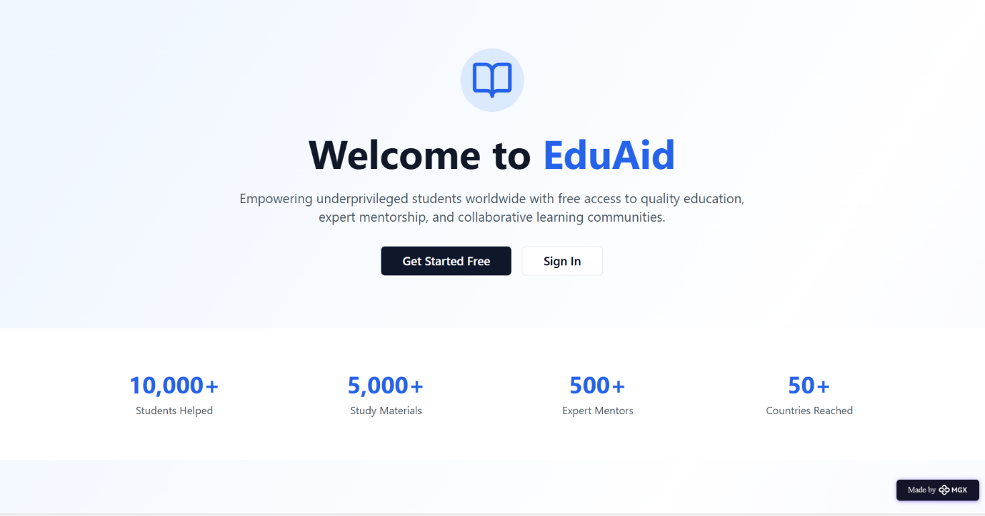

Join EduAid Page:

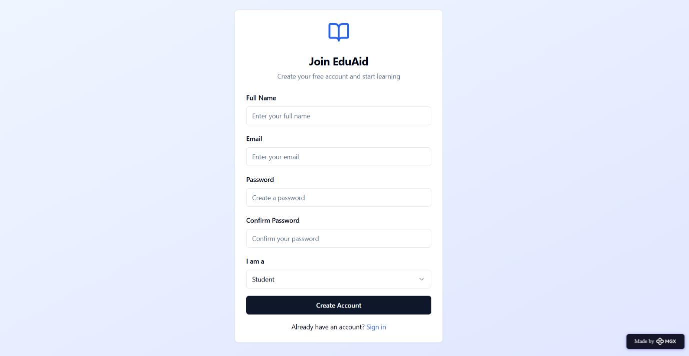

**User Dashboard:**

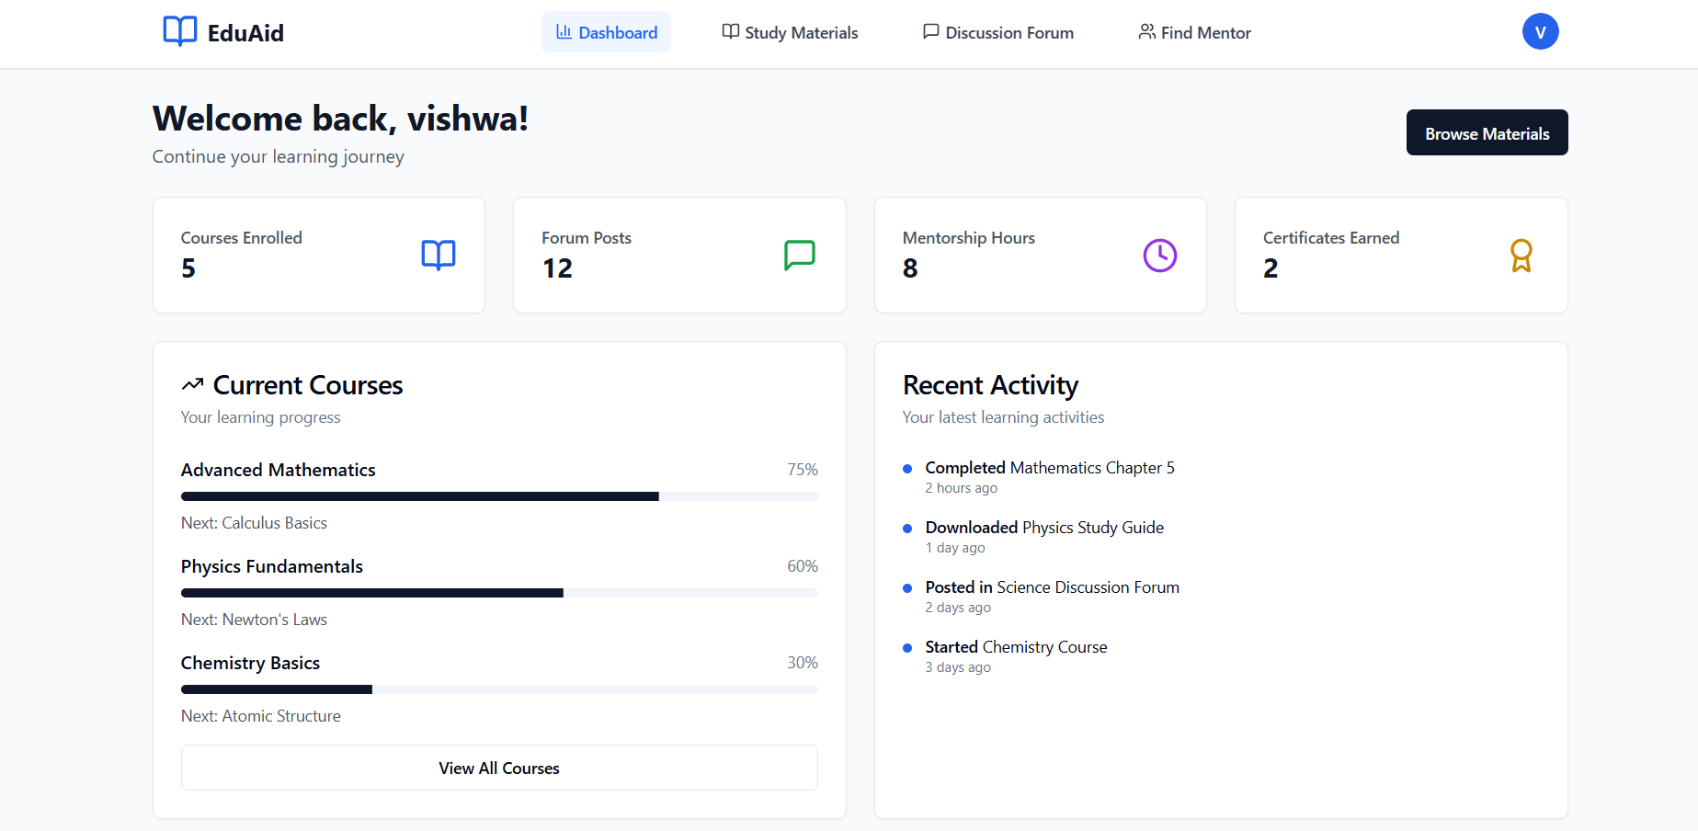

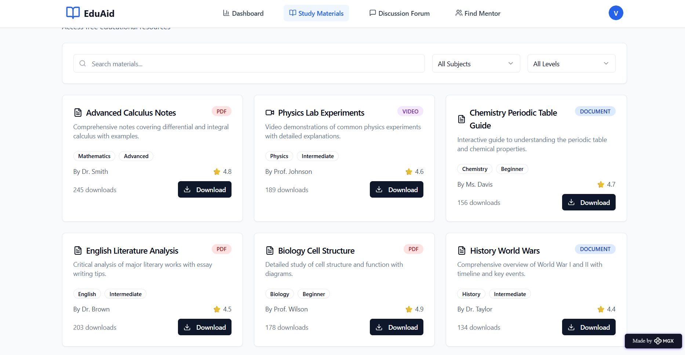

**Study Materials Section:**

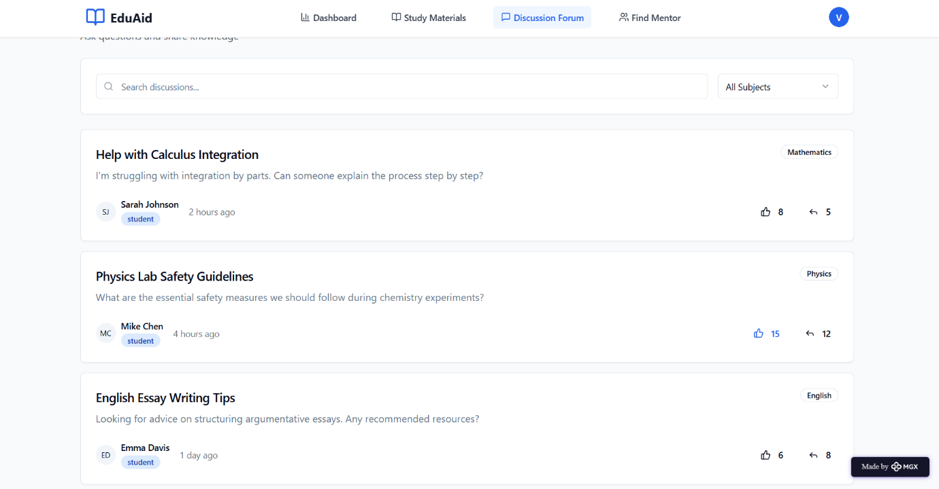

**Mentorship Sessions:**

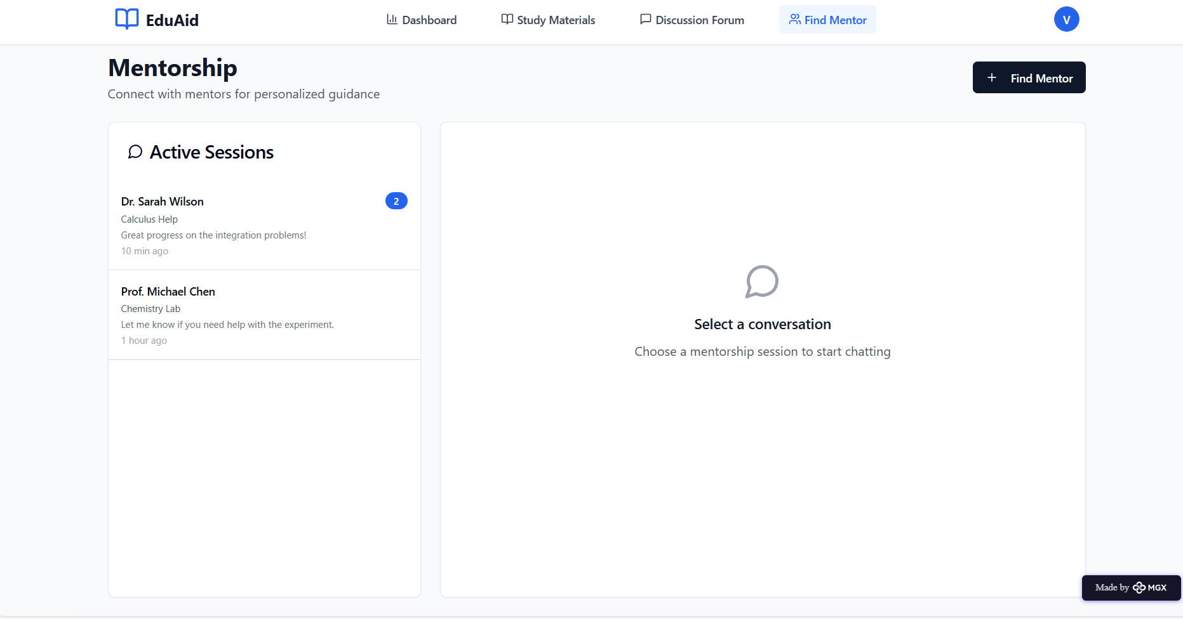

*Step 7: Test – Getting Feedback*

* Who did I share my solution with?

I shared my **EduAid -Free E-Learning & Mentorship Web Application** solution with:

* **Students** – from local colleges and schools to test usability and accessibility.
* **Teachers and career guidance counsellors**  – to evaluate the effectiveness of study material sharing and mentorship features.
* **Parents of rural students** – to understand their perspective on how the platform supports their children’s learning
* **Peers and mentors** – for feedback on design, functionality, and ease of use.

What feedback did I receive?

**Feedback: Pros and Cons**

**Pros (Positive Insights from Feedback):**

1. Students found the platform easy to use and helpful for accessing free study materials.

2. Teachers appreciated the mentorship feature for guiding students directly through chat.

3. The discussion forum and progress tracking system were highlighted as valuable and engaging.

4. The design was clear, responsive, and mobile-friendly, making it accessible to rural learners.

5. Parents liked the idea of a free learning system that supports their children’s education without extra cost.

**Cons (Areas to Improve Noted in Feedback):**

1. Some users felt the chatbot replies could be made more natural and interactive.

2. Limited number of subjects and materials available in the prototype version.

3. The mentorship chat feature occasionally lagged during testing.

4. Forum moderation and filtering could be improved to maintain quality discussions.

5. Users requested offline access or downloadable notes for better usability.

**My Response for The Feedback:**  
I plan to improve EduAid by making the chatbot responses more natural and engaging using advanced AI models.  
More subjects and study materials will be added to cover a wider range of topics.  
The mentorship chat will be optimized for faster and smoother communication.  
Forum moderation tools will be introduced to maintain quality discussions.  
I will also include an offline download option for students with limited internet access.  
These updates will make EduAid more interactive, accessible, and user-friendly.

👍 What works well:

**What Works Well**

* **User-Friendly Interface**: EduAid’s clean and simple design makes it easy for students and mentors to navigate.
* **Free Access to Resources:** Students can access study materials and mentorship without any cost.
* **AI Chat Support:** The chatbot helps users find materials and guidance instantly.
* **Progress Tracking:** The dashboard visually shows student achievements and completed lessons.
* **Mobile Compatibility**: Works smoothly on both desktop and mobile, making it accessible for all learners.
* **Interactive Forum:** The discussion board encourages collaboration between students and teachers.

🔧 What needs improvement:

* **Chatbot Accuracy**: The AI chatbot sometimes gives repetitive or limited responses and needs better contextual understanding**.**
* **Content Variety:** More subjects, languages, and video materials should be added for broader learning coverage.
* **System Performance:** The mentorship chat and forum features need optimization for faster load times.
* **Offline Access:** A downloadable or offline mode should be introduced for students with poor internet connectivity.
* **Collaborations Needed:** To expand functionality, partnerships with **other platforms and organizations** are required.
* **User Experience Enhancements:** Further improvements in **navigation, visuals, and engagement** could make the app more intuitive and appealing.

*AI Tools you can use for Step 6-7:*

**ChatGPT/Perplexity AI/Claude AI/Canva AI/Chatling AI/Figma AI/Metamgx/Gamma AI**: You can use these tools to build solutions/models or mock-up dummy prototypes

***Day 4: Showcase***

*Step 8: Presenting my Innovation:*I am presenting **EduAid — Free E-Learning & Mentorship Web Application**, a platform created to make quality education accessible for all.  
EduAid allows students to learn, discuss, and connect with mentors anytime and anywhere.  
It provides free study materials, a mentorship chat system, and a collaborative discussion forum.  
The platform also includes a progress tracking dashboard that helps students monitor their learning growth.  
Built using **Meta MGX**, **ChatGPT**, and **Figma AI**, EduAid combines the power of AI and no-code design for smooth functionality.

**Impact:** EduAid bridges the educational gap for underprivileged students, promotes digital learning, and supports equal opportunities for academic success.

**<SHOWCASE YOUR INNOVATION TO YOUR PEERS>**



*Step 9: Reflections*

* What did I enjoy the most during this project-based learning activity?

I enjoyed designing and developing **EduAid** using AI tools like ChatGPT and Meta MGX. It was exciting to see my idea turn into a working web platform that supports students and mentors. Creating the mentorship chat system and discussion forum was a fun and meaningful learning experience.

What was my biggest challenge during this project-based learning activity?

My biggest challenge was integrating different features—like chat, forum, and progress tracking—into one smooth platform.I also had to ensure that EduAid remained easy to use, visually appealing, and accessible for rural students.

**Take-home task**

*https://github.com/vishwaaa0118-hash/EduAid-Free-E-Learning-Mentorship-Web-Application*

*AI Tools you can use for Step 8:*

**Canva AI:** You can use this to design your pitch document. Download your pitch document as a PDF file and upload on GitHub